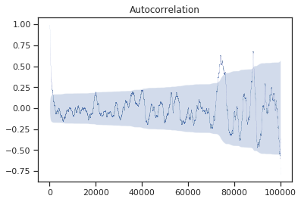
SUBSAMPLING
Once data has been gathered there’s the need to verify that all samples are independent random variables as most of the work relies on this assumption. The next figure depicts a correlogram for the ART. As it’s clear, it exhibits a high degree of correlation over all lags. To cope with this issue a iterative subsampling as been performed. What fallows is the pseudo-code for the aforementioned process:

subsample(vector, k) // k > 1
p = 1/k
initialize new_vector
for x in vector
insert x in new_vector with probability p
if samples in new_vector are incorrelated
return new_vector
else
subsample(vector, k+1)

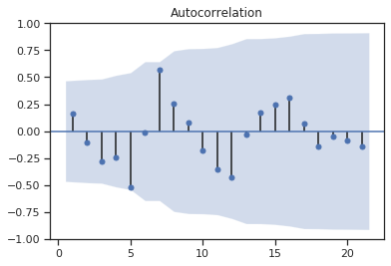
The resulting shrinked sample size is what is called effective sample size (our results matches the predictions made in [1] (12)) and will be used in all of estimations of confidence interval that henceforth will be made. The correlogram for the subsampled vectors is depicted in the following figure

[1] Zieba A (2010) Effective number of observations and unbiased estimators of variance for autocorrelated data—an overview

DISTRIBUTIONS OF THE SYSTEM
It is now interesting to spot what distributions the quantities under analysis are generated from, and possibly, parametrize them. To achieve this goal a preliminary QQ-Plot analysis has been carried on. The distributions that characterize our system are exponential (for DQWT and HQWT), geometric (for DQS and HQS), Poisson (for PP) and hyper-geometric(for ART)[qui metti una nota per dire che in letteratura esistono due definizioni diverse id hyperexponential). In the next 6 figure an example of QQ-Plot for each of this quantities is reported.

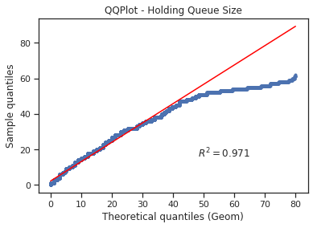
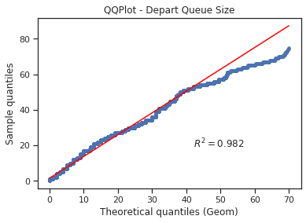

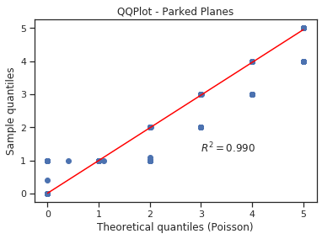

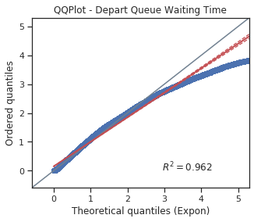

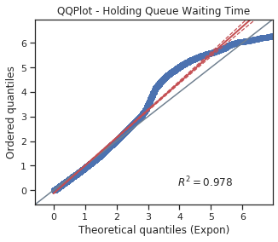
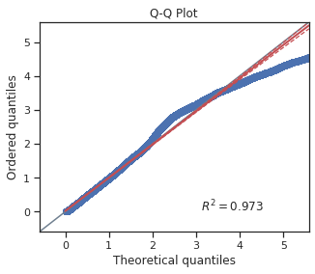

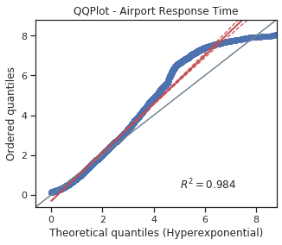

Once the distributions have been spotted we proceeded to parametrize them, that is, to find the parameters that better suit in our scenario. To this scope we addressed to the Maximum Likelihood Estimation (MLE). Without delving into calculations, the following table reports the results of such analysis
 | Distribution | Quantities | Parameter
 | Exponential | HQWT, DQWT | n/somma_dei_sample (n/x_bar oppure 1/sample_mean)
 | Geometric | HQS, DQS | Come sopra
 | Poisson | PP | Sample_mean, va bene così o la formula con la sommatoria
 | Hyper-Exponential | ART | 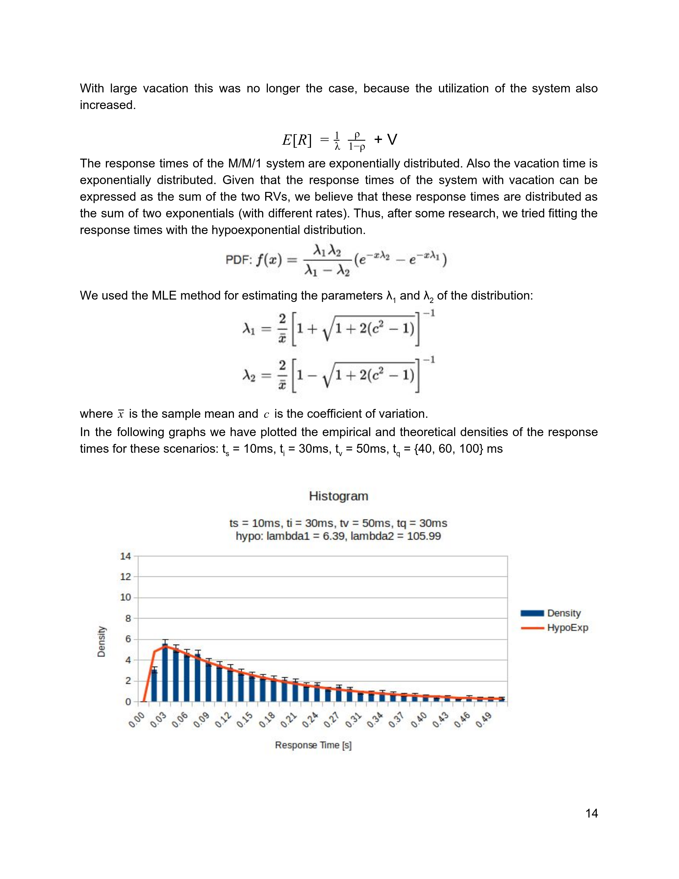  Le formule sono lì, il c è il sample coefficient of variation
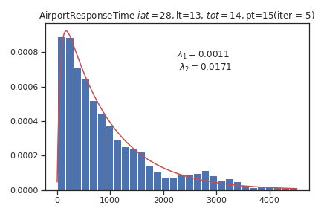
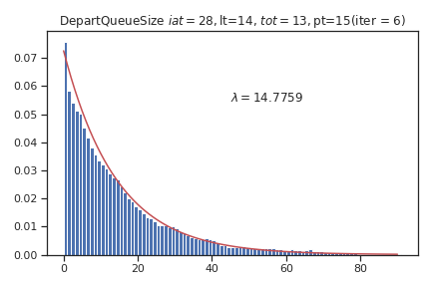

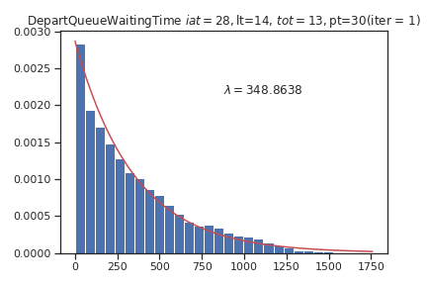
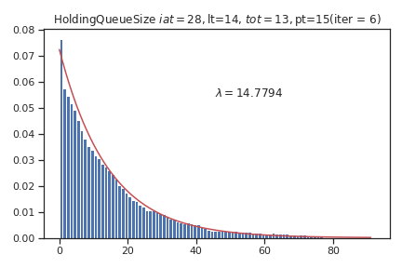

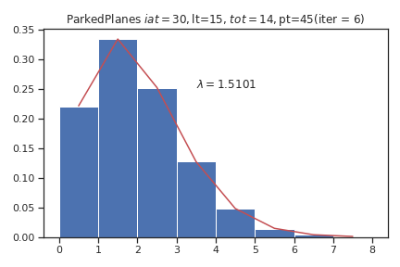
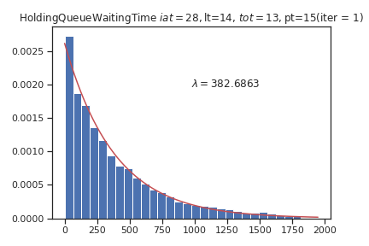

Notice that the rate of the Poisson distribution describing PPs is merely iat/pt. This knowledge let us know the probability that there are k planes parked in the airport

